

ARTIFICIAL INTELLIGENCE LAB

**Subject Code: (18CSC305J)**

B.TECH IiI Year / VI Semester

**NAME-**

**REG. No.-**



DEPARTMENT OF COMPUTER SCIENCE ENGINEERING

FACULTY OF ENGINEERING & TECHNOLOGY

SRM INSTITUTE OF SCIENCE & TECHNOLOGY,

MODINAGAR

Even Semester (JAN-2021)

**BONAFIDE CERTIFICATE**

## Registration no.

*Certified to be the bonafide record of work done by*

*Of 6th semester 3rd year B.TECH degree course in SRM INSTITUTE OF SCIENCE & TECHNOLOGY, DELHI-NCR Campus for the Department of* ***Computer Science & Engineering,*** *in Artificial Intelligence Laboratory during the academic year* ***2020-21.***

**Lab In charge Head of the department**

*Submitted for end semester examination held on / / at SRM INSTITUTE OF SCIENCE & TECHNOLOGY, DELHI-NCR Campus.*

***Internal Examiner-I Internal Examiner-II***

**INDEX**

|  |  |  |  |  |  |
| --- | --- | --- | --- | --- | --- |
| Exp  .  No. | Title of Experiment | Page No. | Date of Experiment | Date of Completion of Experiment | Teacher’s Signature |
| **1** | Implementation of Toy problem Example-Implement water jug problem |  |  |  |  |
| **2** | Developing Agent Program for Real World Problem. |  |  |  |  |
| **3** | Implementation of Constraint satisfaction problem, Example: Implement N- queen Problem |  |  |  |  |
| **4** | To Implementation and Analysis of BFS and DFS for Application. |  |  |  |  |
| **5** | To implement Best first search and A*  algorithm. |  |  |  |  |
| **6** | To implement Minimax Algorithm. |  |  |  |  |
| **7** | Implementation of unification and resolution  for real world problems. |  |  |  |  |
| **8** | Implementation of knowledge  representation schemes – use cases. |  |  |  |  |
| **9** | Implementation of uncertain methods for an  application. |  |  |  |  |
| **10** | Implementation of block world problem. |  |  |  |  |
| **11** | Implementation of Learning Algo |  |  |  |  |
| **12** | Development of ensemble model |  |  |  |  |
| **13** |  |  |  |  |  |

# Experiment 1

* **Aim –** Implementation of Toy problem Example-Implement water jug problem.

### Algorithm –

|  |  |  |
| --- | --- | --- |
| **Rule** | **State** | **Process** |
| **1** | (X,Y | X<4) | (4,Y)  {Fill 4-gallon jug} |
| **2** | (X,Y |Y<3) | (X,3)  {Fill 3-gallon jug} |
| **3** | (X,Y |X>0) | (0,Y)  {Empty 4-gallon jug} |
| **4** | (X,Y | Y>0) | (X,0)  {Empty 3-gallon jug} |
| **5** | (X,Y | X+Y>=4 ^ Y>0) | (4,Y-(4-X))  {Pour water from 3-gallon jug into 4-gallon jug until 4-gallon jug is full} |
| **6** | (X,Y | X+Y>=3  ^X>0) | (X-(3-Y),3)  {Pour water from 4-gallon jug into 3-gallon jug until 3-gallon jug is full} |
| **7** | (X,Y | X+Y<=4  ^Y>0) | (X+Y,0)  {Pour all water from 3-gallon jug into 4-gallon jug} |
| **8** | (X,Y | X+Y <=3^ X>0) | (0,X+Y)  {Pour all water from 4-gallon jug into 3-gallon jug} |
| **9** | (0,2) | (2,0)  {Pour 2 gallon water from 3 gallon jug into 4 gallon jug} |

* **Code –**

print("Water jug problem") x=int(input("Enter X : "))

y=int(input("Enter Y : ")) while True:

rn=int(input("Enter the rule no. : ")) if rn==2:

if y<3:

x=0 y=3

if rn==3:

if x>0:

x=0

y=3

if rn==5:

if x+y>4:

x=4

y=y-(4-x)

if rn==7:

if x+y<4:

x=x+y

y=0

if rn==9:

x=2

y=0

print("X=",x)

print("Y=",y)

if x==2:

print("The result is a goal state") break

* **Result –**

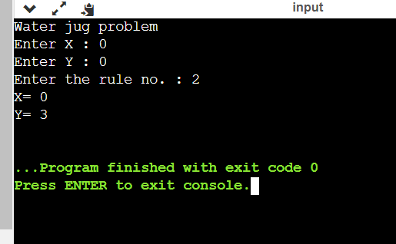

# Experiment 2

* **Aim –** Developing Agent Program for Real World Problem.

### Algorithm –

1. Initialize goal_state to {'A':'0','B':'0'} where 0 indicates Clean and 1 indicates
2. Initialize cost to 0.
3. Accept the input from the user namely location of vacuum and status of rooms.
4. If the location with vacuum is A, check the status of both A and B, modify the state andcost accordingly.
5. Else the location with vacuum is B, check the status of the rooms, modify the state andcost.
6. Display the goal state and the performance measurement stored in cost.

* **Code –**

import random

class Environment(object): def init (self):

self.locationCondition = {'A': '0', 'B': '0'} self.locationCondition['A'] = random.randint(0, 1) self.locationCondition['B'] = random.randint(0, 1)

class SimpleReflexVacuumAgent(Environment): def init (self, Environment):

print (Environment.locationCondition)

Score = 0

vacuumLocation = random.randint(0, 1) if vacuumLocation == 0:

print ("Vacuum is randomly placed at Location A") if Environment.locationCondition['A'] == 1:

print ("Location A is Dirty. ") Environment.locationCondition['A'] = 0;

Score += 1

print ("Location A has been Cleaned. :D") if Environment.locationCondition['B'] == 1:

print ("Location B is Dirty.") print ("Moving to Location B...") Score -= 1

Environment.locationCondition['B'] = 0;

Score += 1

print ("Location B has been Cleaned :D.")

else:

if Environment.locationCondition['B'] == 1: print ("Location B is Dirty.")

Score -= 1

print ("Moving to Location B...") Environment.locationCondition['B'] = 0;

Score += 1

print ("Location B has been Cleaned. :D") elif vacuumLocation == 1:

print ("Vacuum is randomly placed at Location B. ") if Environment.locationCondition['B'] == 1:

print ("Location B is Dirty") Environment.locationCondition['B'] = 0;

Score += 1

print ("Location B has been Cleaned")

if Environment.locationCondition['A'] == 1: print ("Location A is Dirty")

Score -= 1

print ("Moving to Location A") Environment.locationCondition['A'] = 0;

Score += 1

print ("Location A has been Cleaned")

else:

if Environment.locationCondition['A'] == 1: print ("Location A is Dirty")

print ("Moving to Location A") Score -= 1

Environment.locationCondition['A'] = 0;

Score += 1

print ("Location A has been Cleaned") print (Environment.locationCondition)

print ("Performance Measurement: " + str(Score)) theEnvironment = Environment()

theVacuum = SimpleReflexVacuumAgent(theEnvironment)

* **Result –**

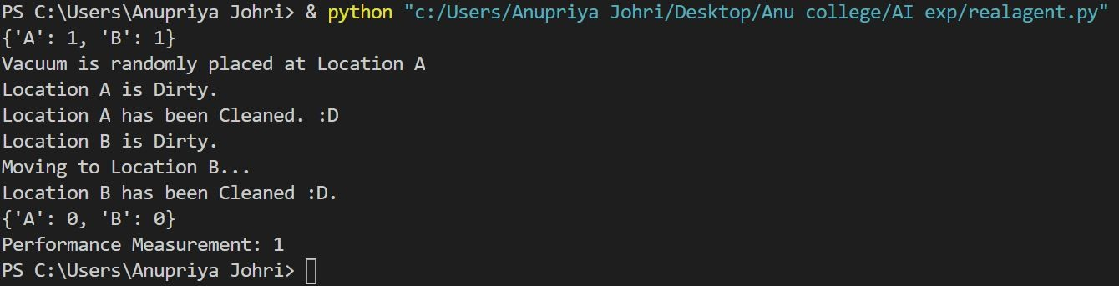

# Experiment 3

* **Aim –** Implementation of Constraint satisfaction problem Example: Implement N- queen Problem

### Algorithm –

1)Start in the leftmost column

2)If all queens are placed return true

3)Try all rows in the current column. Do following for every tried row.

a)If the queen can be placed safely in this row then mark this [row, column] as part of the solution and recursively check if placing queen here leads to a solution.

b)If placing queen in [row, column] leads to a solution then return true.

c) If placing queen doesn't lead to a solution then unmark this [row, column] (Backtrack) and go to step (a) to try other rows.

4) If all rows have been tried and nothing worked, return false to trigger backtracking.

### Code –

global N

N=int(input("enter no of queens : ")) def printSolution(board):

for i in range(N): for j in range(N):

print(board[i][j],end=" ") print(" ")

def isSafe(board,row,col): for i in range(col):

if board[row][i]=='Q': return False

for i,j in zip(range(row,-1,-1), range(col,-1,-1)): if board[i][j]=='Q':

return False

for i,j in zip(range(row,N,1), range(col,-1,-1)): if board[i][j]=='Q':

return False return True

def solveNQUtil(board,col): if col>=N:

return True

for i in range(N):

if isSafe(board,i,col): board[i][col]='Q'

if solveNQUtil(board,col+1) == True: return True

board[i][col]=0

return False

def solveNQ():

board = [[0 for i in range(N)] for j in range(N)]

if solveNQUtil(board,0)==False: print("Solution does not exist") return False

printSolution(board) return True

solveNQ()

* **Result –**

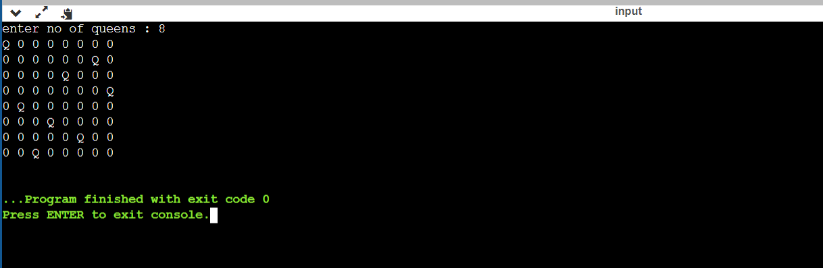

# Experiment 4

* **Aim –** To Implementation and Analysis of BFS and DFS for Application.

### Algorithm –

**BFS :**

Consider G as a graph which we are going to traverse using the BFS algorithm. Let S be the root/starting node of the graph.

* **Step 1:** Start with node S and enqueue it to the queue.
* **Step 2:** Repeat the following steps for all the nodes in the graph.
* **Step 3:** Dequeue S and process it.
* **Step 4:** Enqueue all the adjacent nodes of S and process them.
* [END OF LOOP]
* **Step 6:** EXIT

## DFS:

* **Step 1:** Insert the root node or starting node of a tree or a graph in the stack.
* **Step 2:** Pop the top item from the stack and add it to the visited list.
* **Step 3:** Find all the adjacent nodes of the node marked visited and add the ones that are not yet visited, to the stack.
* **Step 4**: Repeat steps 2 and 3 until the stack is empty.

### Code –

**BFS:**

from queue import Queue

graph = {

0 : [1,2,3],

1 : [0,4],

2 : [0,4],

3 : [0,4],

4 : [1,2,3]

}

print("The adjacency List representing the graph is:") print(graph)

def bfs(graph, source): Q = Queue()

visited_vertices = set()

Q.put(source) visited_vertices.update({1})

while not Q.empty():

vertex = Q.get()

print(vertex, end=" ")

for u in graph[vertex]:

if u not in visited_vertices:

Q.put(u)

visited_vertices.update({u})

print("BFS traversal of graph with source 1 is:")

bfs(graph, 1)

### 

**Result –**

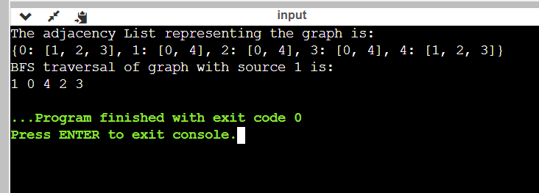

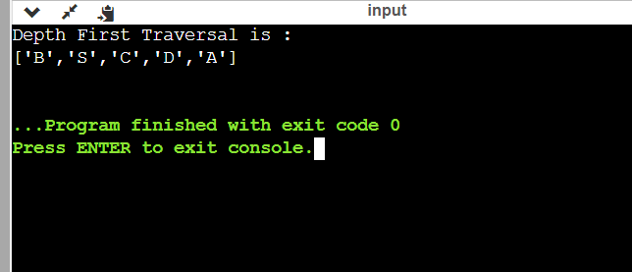

**Experiment 5**

* **Aim-**To implement Best First Search and A* algorithm.

### Algorithm-

**1. Best First Search-**

Step 1: Place the starting node into the OPEN list.

Step 2: If the OPEN list is empty, Stop and return failure.

Step 3: Remove the node n, from the OPEN list which has the lowest value of h(n), and places it in the CLOSED list.

If node n is goal then return else

Step 4: Expand the node n, and generate and check the successors of node n. and find whether any node is a goal node or not. If any successor node is goal node, then return success and terminate the search, else proceed to Step 5.

Step 5: For each successor node, algorithm checks for evaluation function f(n), and then check if the node has been in either OPEN or CLOSED list. If the node has not been in both list, then add it to the OPEN list.

Step 6: Return to Step 2.

### 2. A*-

Step1: Place the starting node in the OPEN list.

Step 2: Check if the OPEN list is empty or not, if the list is empty then return failure and stops.

Step 3: Select the node from the OPEN list which has the smallest value of evaluation function (g+h), if node n is goal node then return success and stop, otherwise

Step 4:Expand node n and generate all of its successors, and put n into the closed list. For each successor n', check whether n' is already in the OPEN or CLOSED list, if not then compute evaluation function for n' and place into Open list.

Step 5: Else if node n' is already in OPEN and CLOSED, then it should be attached to the back pointer which reflects the lowest g(n') value.

Step 6: Return to Step 2.

### Code-

**1. Best First Search-**

# This class represent a graph class Graph:

# Initialize the class

def init (self, graph_dict=None, directed=True): self.graph_dict = graph_dict or {}

self.directed = directed if not directed:

self.make_undirected()

# Create an undirected graph by adding symmetric edges def make_undirected(self):

for a in list(self.graph_dict.keys()):

for (b, dist) in self.graph_dict[a].items():

self.graph_dict.setdefault(b, {})[a] = dist

# Add a link from A and B of given distance, and also add the inverse link if the graph is undirected

def connect(self, A, B, distance=1): self.graph_dict.setdefault(A, {})[B] = distance if not self.directed:

self.graph_dict.setdefault(B, {})[A] = distance # Get neighbors or a neighbor

def get(self, a, b=None):

links = self.graph_dict.setdefault(a, {}) if b is None:

return links else:

return links.get(b)

# Return a list of nodes in the graph def nodes(self):

s1 = set([k for k in self.graph_dict.keys()])

s2 = set([k2 for v in self.graph_dict.values() for k2, v2 in v.items()]) nodes = s1.union(s2)

return list(nodes)

# This class represent a node class Node:

# Initialize the class

def init (self, name:str, parent:str): self.name = name

self.parent = parent

self.g = 0 # Distance to start node self.h = 0 # Distance to goal node self.f = 0 # Total cost

# Compare nodes

def eq (self, other):

return self.name == other.name # Sort nodes

def lt (self, other): return self.f < other.f

# Print node

def repr (self):

return ('({0},{1})'.format(self.position, self.f)) # Best-first search

def best_first_search(graph, heuristics, start, end):

# Create lists for open nodes and closed nodes open = []

closed = []

# Create a start node and an goal node start_node = Node(start, None) goal_node = Node(end, None)

# Add the start node open.append(start_node)

# Loop until the open list is empty while len(open) > 0:

# Sort the open list to get the node with the lowest cost first open.sort()

# Get the node with the lowest cost current_node = open.pop(0)

# Add the current node to the closed list closed.append(current_node)

# Check if we have reached the goal, return the path if current_node == goal_node:

path = []

while current_node != start_node: path.append(current_node.name + ': ' + str(current_node.g)) current_node = current_node.parent

path.append(start_node.name + ': ' + str(start_node.g)) # Return reversed path

return path[::-1] # Get neighbours

neighbors = graph.get(current_node.name) # Loop neighbors

for key, value in neighbors.items(): # Create a neighbor node

neighbor = Node(key, current_node)

# Check if the neighbor is in the closed list if(neighbor in closed):

continue

# Calculate cost to goal

neighbor.g = current_node.g + graph.get(current_node.name, neighbor.name) neighbor.h = heuristics.get(neighbor.name)

neighbor.f = neighbor.h

# Check if neighbor is in open list and if it has a lower f value if(add_to_open(open, neighbor) == True):

# Everything is green, add neighbor to open list open.append(neighbor)

# Return None, no path is found return None

# Check if a neighbor should be added to open list

def add_to_open(open, neighbor): for node in open:

if (neighbor == node and neighbor.f >= node.f): return False

return True

# The main entry point for this module def main():

# Create a graph graph = Graph()

# Create graph connections (Actual distance) graph.connect('Jaipur', 'Gurugram', 111)

graph.connect('Jaipur', 'Mumbai', 85)

graph.connect('Gurugram', 'Noida', 104)

graph.connect('Gurugram', 'Sitapur', 140)

graph.connect('Gurugram', 'Delhi', 183)

graph.connect('Mumbai', 'Noida', 230)

graph.connect('Mumbai', 'Kolkata', 67)

graph.connect('Kolkata', 'Bilaspur', 191)

graph.connect('Kolkata', 'Sitapur', 64)

graph.connect('Noida', 'Delhi', 171)

graph.connect('Noida', 'Madurai', 170)

graph.connect('Noida', 'Pondicherry', 220)

graph.connect('Sitapur', 'Delhi', 107)

graph.connect('Bilaspur', 'Bern', 91)

graph.connect('Bilaspur', 'Zurich', 85)

graph.connect('Bern', 'Zurich', 120)

graph.connect('Zurich', 'Memmingen', 184)

graph.connect('Memmingen', 'Delhi', 55)

graph.connect('Memmingen', 'Madurai', 115)

graph.connect('Madurai', 'Delhi', 123)

graph.connect('Madurai', 'Pondicherry', 189)

graph.connect('Madurai', 'Raipur', 59)

graph.connect('Raipur', 'Shimla', 81)

graph.connect('Pondicherry', 'Lucknow', 102)

graph.connect('Shimla', 'Lucknow', 126)

# Make graph undirected, create symmetric connections graph.make_undirected()

# Create heuristics (straight-line distance, air-travel distance) heuristics = {}

heuristics['Bilaspur'] = 204

heuristics['Bern'] = 247

heuristics['Jaipur'] = 215

heuristics['Kolkata'] = 137

heuristics['Lucknow'] = 318

heuristics['Mumbai'] = 164

heuristics['Madurai'] = 120

heuristics['Memmingen'] = 47

heuristics['Noida'] = 132

heuristics['Pondicherry'] = 257

heuristics['Raipur'] = 168

heuristics['Sitapur'] = 75

heuristics['Shimla'] = 236

heuristics['Gurugram'] = 153

heuristics['Zurich'] = 157

heuristics['Delhi'] = 0 # Run search algorithm

path = best_first_search(graph, heuristics, 'Jaipur', 'Delhi') print(path)

print()

# Tell python to run main method

if name == " main ": main()

### 2. A*-

from queue import PriorityQueue

#Creating Base Class class State(object):

def init (self, value, parent, start = 0, goal = 0): self.children = []

self.parent = parent self.value = value self.dist = 0

if parent:

self.start = parent.start self.goal = parent.goal self.path = parent.path[:] self.path.append(value)

else:

self.path = [value] self.start = start self.goal = goal

def GetDistance(self): pass

def CreateChildren(self): pass

# Creating subclass

class State_String(State):

def init (self, value, parent, start = 0, goal = 0 ): super(State_String, self). init (value, parent, start, goal) self.dist = self.GetDistance()

def GetDistance(self):

if self.value == self.goal: return 0

dist = 0

for i in range(len(self.goal)): letter = self.goal[i]

dist += abs(i - self.value.index(letter)) return dist

def CreateChildren(self): if not self.children:

for i in range(len(self.goal)-1): val = self.value

val = val[:i] + val[i+1] + val[i] + val[i+2:] child = State_String(val, self) self.children.append(child)

# Creating a class that hold the final magic class A_Star_Solver:

def init (self, start, goal): self.path = [] self.vistedQueue =[]

self.priorityQueue = PriorityQueue() self.start = start

self.goal = goal

def Solve(self):

startState = State_String(self.start,0,self.start,self.goal)

count = 0

self.priorityQueue.put((0,count, startState)) while(not self.path and self.priorityQueue.qsize()):

closesetChild = self.priorityQueue.get()[2] closesetChild.CreateChildren() self.vistedQueue.append(closesetChild.value) for child in closesetChild.children:

if child.value not in self.vistedQueue: count += 1

if not child.dist:

self.path = child.path break

self.priorityQueue.put((child.dist,count,child)) if not self.path:

print("Goal Of is not possible !" + self.goal ) return self.path

# Calling all the existing stuffs if name == " main ":

start1 = "anupriya" goal1 = "ayirpuna" print("Starting. ")

a = A_Star_Solver(start1,goal1) a.Solve()

for i in range(len(a.path)): print("{0}){1}".format(i,a.path[i]))

### Result-

1. **Best First Search-**

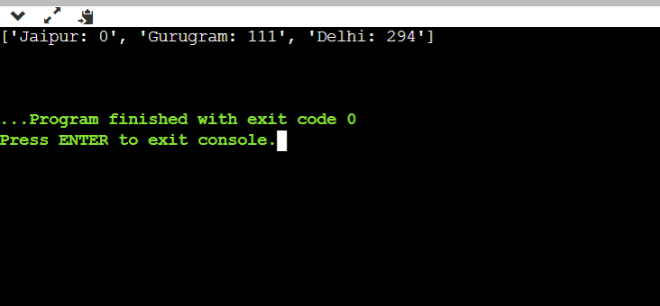

**2. A*-**

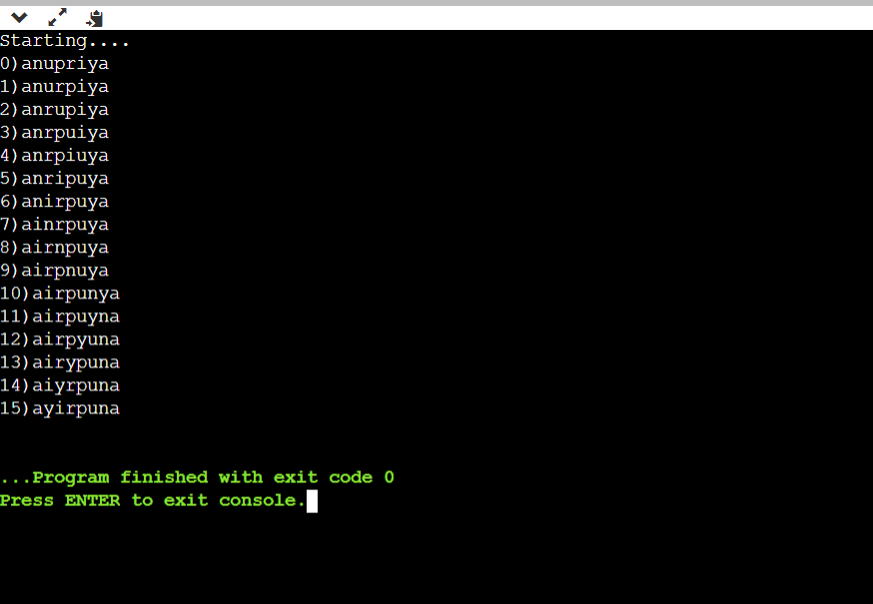

# Experiment 6

* **Aim –** To implement Minimax Algorithm.

### Algorithm –

function minimax(node, depth, Player)

* 1. if depth ==0 or node is a terminal node then return value(node)
  2. If Player =‘Max’ // for **Maximizer Player**

set **α = -∞** //**worst case value for MAX**

for each child of node do

value= minimax(child, depth-1, ’MIN’)

α= max(α, Value) //gives Maximum of the values return (α)

**else** // for **Minimizer player**

set **α = +∞** //**worst case value for MIN**

for each child of node do

value= minimax(child, depth-1, ’MAX’)

α = min(α, Value) //gives minimum of the values return (α)

### Code –

import math

def minimax (curDepth, nodeIndex, maxTurn, scores,targetDepth) : if(curDepth==targetDepth):

return scores[nodeIndex] if(maxTurn):

return max(minimax(curDepth+1, nodeIndex*2,False,scores,targetDepth),minimax(curDepth+1, nodeIndex*2+1,False,scores,targetDepth))

else:

return min(minimax(curDepth+1, nodeIndex*2,True,scores,targetDepth),minimax(curDepth+1, nodeIndex*2+1,True,scores,targetDepth))

scores=[-1,4,2,6,-3,-5,0,7]

treeDepth=math.log(len(scores),2) print("Optimal value is : ",end=" ") print(minimax(0,0,True,scores,treeDepth))

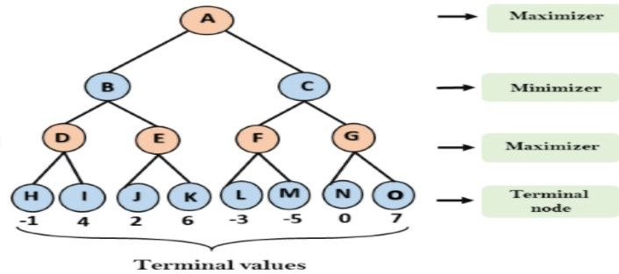

* **Result –**

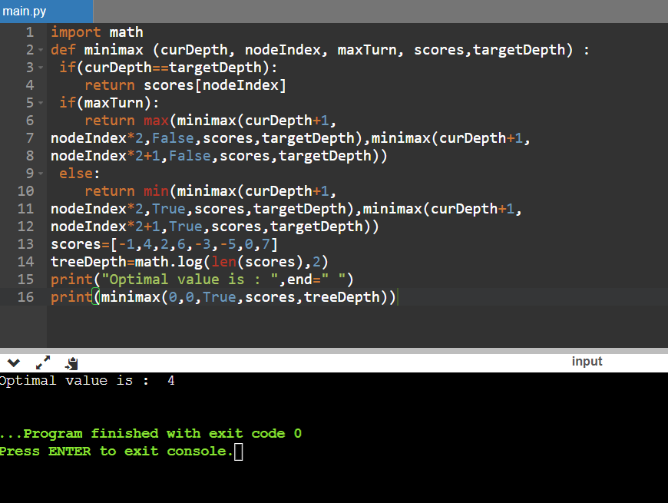

# Experiment 7

* **Aim –** Implementation of unification and resolution for real world problems.

### Algorithm–

**Prolog unification**

When programming in Prolog, we spend a lot of time thinking about how variables and rules "match" or "are assigned." There are actually two aspects to this. The first, "unification," regards how terms are matched and variables assigned to make terms match. The second, "resolution," is described in [separate](https://cse3521.artifice.cc/prolog-resolution.html) [notes](https://cse3521.artifice.cc/prolog-resolution.html). Resolution is only used if rules are involved. You may notice in these notes that no rules are involved since we are only talking about unification.

**Terms**

Prolog has three kinds of **terms**:

1. Constants like 42 (numbers) and franklin (atoms, i.e., lower-case words).
2. Variables like X and Person (words that start with upper-case).
3. Complex terms like parent(franklin, bo) and baz(X, quux(Y)) Two terms **unify** if they can be matched. Two terms can be matched if:
   * they are the same term (obviously), or
   * they contain variables that can be unified so that the two terms without variables are the same.

For example, suppose our knowledge base is:

**woman**(mia). **loves**(vincent, angela). **loves**(franklin, mia).

* + mia and mia unify because they are the same.
  + mia and X unify because X can be given the value mia so that the two terms (without variables) are the same.
  + woman(mia) and woman(X) unify because X can be set to mia which results in identical terms.
  + loves(X, mia) and loves(vincent, X) **cannot** unify because there is no assignment for X (given our knowledge base) that makes the two terms identical.
  + loves(X, mia) and loves(franklin, X) also cannot unify (can you see why?).

We saw in the [Prolog](https://cse3521.artifice.cc/prolog.html) notes that we can "query" the knowledge base and get, say, all the people who love mia. When we query with loves(X, mia). we are asking Prolog to give us all the values for X that unify. These values are, essentially, the people who love mia.

**Rule :**

term1 and term2 unify whenever:

1. If term1 and term2 are **constants**, then term1 and term2 unify if and only if they are the same atom, or the same number.
2. If term1 is a **variable** and term2 is any type of term, then term1 and term2 unify, and term1 is instantiated to term2. (And vice versa.) (If they are both variables, they're both instantiated to each other, and we say that they share values.)
3. If term1 and term2 are **complex terms**, they unify if and only if:
   1. They have the same **functor** and **arity**. The functor is the "function" name (this functor

is foo: foo(X, bar)). The arity is the number of arguments for the functor (the arity for foo(X, bar) is 2).

* 1. All of their corresponding arguments unify. **Recursion!**
  2. The variable instantiations are compatible (i.e., the same variable is not given two different unifications/values).

1. Two terms unify if and only if they unify for one of the above three reasons (there are no reasons left unstated).

**Example**

We'll use the = predicate to test if two terms unify. Prolog will answer "Yes" if they do, as well as any sufficient variable assignments to make the unification work.

**Do these two terms unify?**

**1.**

?- mia = mia.

**o/p Ans:- Yes from Rule 1 2.**

?- mia = X.

**o/p Ans:-** Yes, from rule 2. 3.

?- X = Y.

o/p Yes, from rule 2.

4.

?- k(s(g), Y) = k(s(g, X), Y).

**Output:**

No, these two terms do not unify because arity of s(g) do not match with the arity of s(g,X) due to which rule 3 fails in recursion.

# Experiment 8

* **Aim –** Implementation of knowledge representation schemes – use cases.

### Semantic relations –

* 1. 1. Ram has a cycle.

1. Ram is a boy.
2. Cycle has a bell.
3. Ram is 12 years old.
4. Cycle has two paddles.

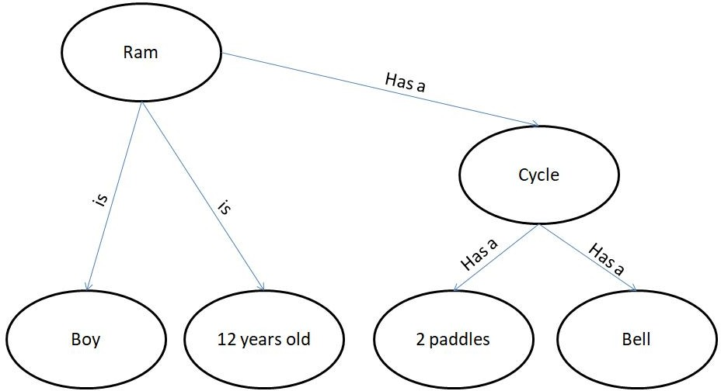

1. 1. Gita likes all kinds of food.
2. Mango and chapati are food.
3. Gita eats almond and is still alive.
4. Anything eaten by anyone and is still alive is food.

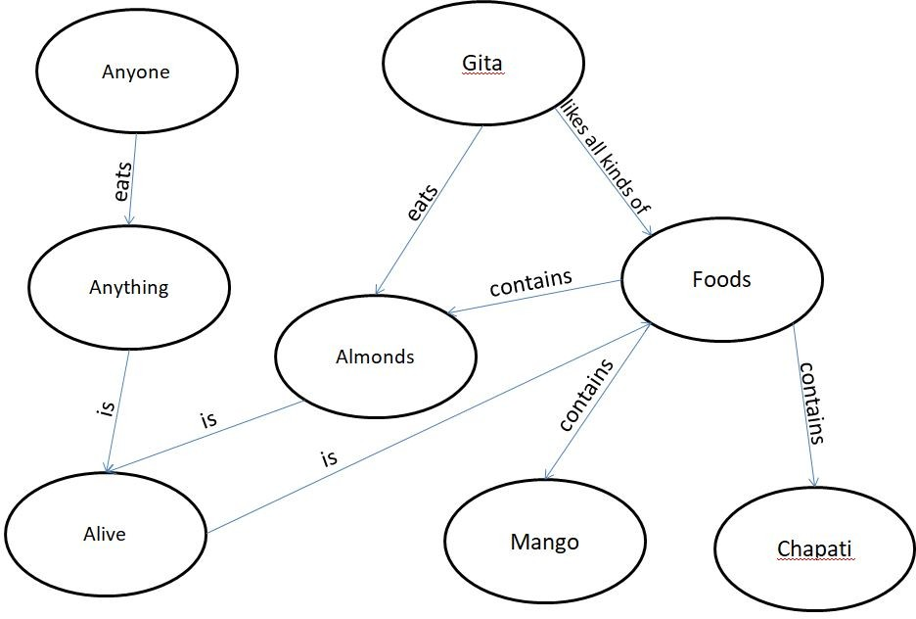

1. 1. Jerry is a cat.
2. Jerry is a mammal
3. Jerry is owned by Priya.
4. Jerry is brown colored.
5. All Mammals are animal.

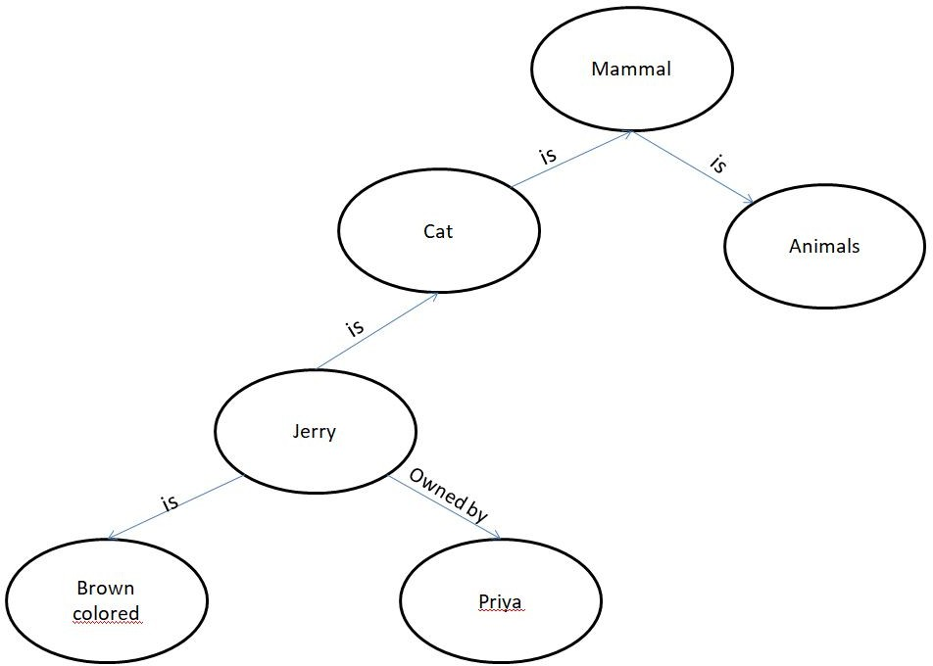

d) 1. Ritz is a car.

1. Car has 4 wheels.
2. Car is a vehicle.
3. Car has engine.
4. Car has battery.
5. Ritz has power steering.

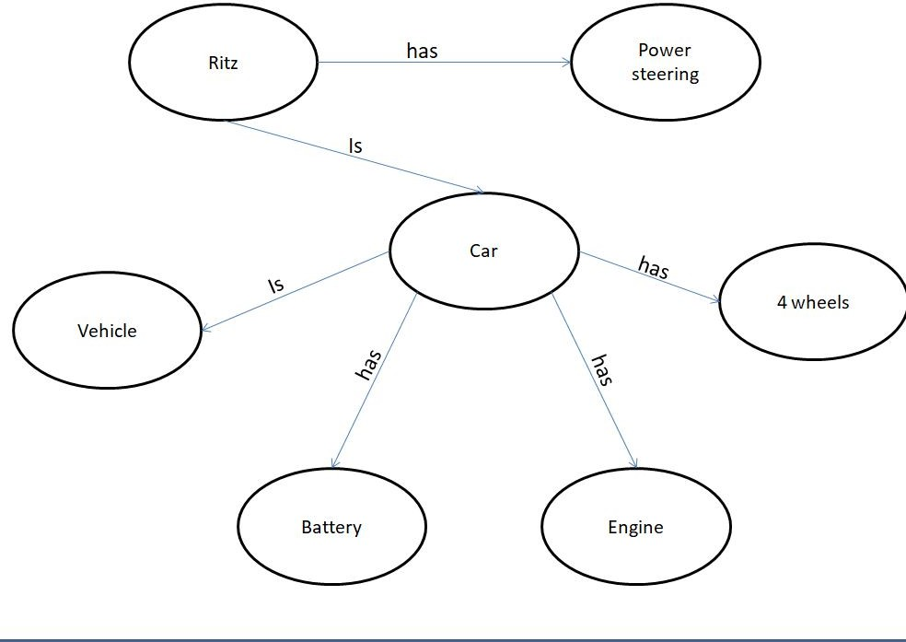

# Experiment 9

* **Aim –** Implementation of uncertain methods for an application.

**Code –** Implementation of Uncertain method for an Application

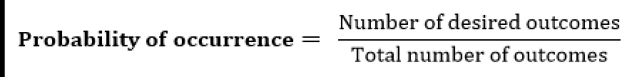

we can find the probability of an uncertain event by using the below formula.

Problem1:- Calculate the Probability of finding how many students got the 60 marks for given data set .

import numpy as np import collections

npArray= np.array([60, 70, 70, 70, 80,90,60])

c=collections.Counter(npArray) # Generate a dictionary {"value":"nbOfOccurrences"}

arraySize=npArray.size

nbOfOccurrences=c[60] #assuming you want the proba to get 10

proba=(nbOfOccurrences/arraySize)*100 print(proba)

print 60.0

Problem2:- If In class 80 students and 60 students got 60 % marks then Calculate the Probability of finding how many students got the 60 marks for given data set .

#!/usr/bin/env python3 """reducer.py""" import sys

# Create a dictionary to map marks Marksprob = {}

# Get input from stdin for line in sys.stdin:

#Remove spaces from beginning and end of the line line = line.strip()

# parse the input from mapper.py ClassA, Marks = line.split('\t', 1

# Create function that returns probability percent rounded to one decimal place def event_probability(event_outcomes, sample_space):

probability = (event_outcomes / sample_space) * 100 return round(probability, 1)

# Sample Space ClassA = 30

# Determine the probability of drawing a heart Marks = 15

grade_probability = event_probability(Marks, ClassA)

# Print each probability print(str(grade_probability) + '%')

**Output**:- 28.57

* **Result – The program has been executed successfully.**

# Experiment 10

* **Aim –** Implementation of block world problem.

### Algorithm –

* 1. MOVE(B,A)- To lift block from B to A.
  2. ON(B,A)- To place block B on A.
  3. CLEAR(B)- To lift block B from the table.
  4. PLACE(B)- To put the block B on table.

### Code –

class Strips(object):

def init (self, name, preconds, effects, cost=1):

self.name = name self.preconds = preconds self.effects = effects self.cost = cost

def repr (self): return self.name

class STRIPS_domain(object):

def init (self, feats_vals, actions): self.feats_vals = feats_vals self.actions = actions

class Planning_problem(object):

def init (self, prob_domain, initial_state, goal): self.prob_domain = prob_domain self.initial_state = initial_state

self.goal = goal boolean = {True, False} ### blocks world

def move(x,y,z):

"""string for the 'move' action""" return 'move_'+x+'_from_'+y+'_to_'+z

def on(x):

"""string for the 'on' feature""" return x+'_is_on'

def clear(x):

"""string for the 'clear' feature""" return 'clear_'+x

def create_blocks_world(blocks = {'a','b','c','d'}): blocks_and_table = blocks | {'table'}

stmap = {Strips(move(x,y,z),{on(x):y, clear(x):True, clear(z):True},

{on(x):z, clear(y):True, clear(z):False})} for x in blocks:

for y in blocks_and_table: for z in blocks:

if x!=y and y!=z and z!=x:

stmap.update({Strips(move(x,y,'table'), {on(x):y, clear(x):True},

{on(x):'table', clear(y):True})}) for x in blocks:

for y in blocks: for z in blocks:

if x!=y:

feats_vals = {on(x):blocks_and_table-{x} for x in blocks} feats_vals.update({clear(x):boolean for x in blocks_and_table})

return STRIPS_domain(feats_vals, stmap) blocks1dom = create_blocks_world({'a','b','c'}) blocks1 = Planning_problem(blocks1dom,

{on('a'):'table', clear('a'):True,

on('b'):'c', clear('b'):True,

on('c'):'table', clear('c'):False}, # initial state

{on('a'):'b', on('c'):'a'}) #goal

blocks2dom = create_blocks_world({'a','b','c','d'})

tower4 = {clear('a'):True, on('a'):'b',

clear('b'):False, on('b'):'c',

clear('c'):False, on('c'):'d',

clear('d'):False, on('d'):'table'}

blocks2 = Planning_problem(blocks2dom, tower4, # initial state

{on('d'):'c',on('c'):'b',on('b'):'a'}) #goal blocks3 = Planning_problem(blocks2dom, tower4, # initial state

{on('d'):'a', on('a'):'b', on('b'):'c'}) #goal

* **Result –** Goal achieved.

### Output –

B

C

A

D

**Experiment-11**

**Aim**-Implementation of Learning Algorithm

**Code:**

# Machine Learning

# Perceptron Algorithm Pyhton function

**import** numpy **as** np

**def** perceptron_single_step_update( feature_vector,

label, current_theta, current_theta_0):

theta = current_theta theta_0 = current_theta_0

**if** label*(np.matmul(current_theta, feature_vector) + current_theta_0) <= 0:

theta = theta + label*feature_vector theta_0 = theta_0 + label

**return** (theta, theta_0)

**def** perceptron(feature_matrix, labels, T): [m,n] = np.shape(feature_matrix)

tt = np.zeros(n) tt_0 = 0

**for** t **in** range(T):

**for** i **in** ra nge(m):

vec = feature_matrix[i]

(tt, tt_0) = perceptron_single_step_update(vec, labels[i], tt, tt_0)

**return** (tt, tt_0)

**Experiment-12**

**Aim**-Development of ensemble model

# importing utility modules import pandas as pd

from sklearn.model_selection import train_test_split from sklearn.metrics import mean_squared_error

# importing machine learning models for prediction from sklearn.ensemble import RandomForestRegressor import xgboost as xgb

from sklearn.linear_model import LinearRegression

# loading train data set in dataframe from train_data.csv file df = pd.read_csv("train_data.csv")

# getting target data from the dataframe target = df["target"]

# getting train data from the dataframe train = df.drop("target")

# Splitting between train data into training and validation dataset X_train, X_test, y_train, y_test = train_test_split(train, target, test_size=0.20)

# initializing all the model objects with default parameters model_1 = LinearRegression()

model_2 = xgb.XGBRegressor() model_3 = RandomForestRegressor()

# training all the model on the training dataset model_1.fit(X_train, y_target) model_2.fit(X_train, y_target) model_3.fit(X_train, y_target)

# predicting the output on the validation dataset pred_1 = model_1.predict(X_test)

pred_2 = model_2.predict(X_test) pred_3 = model_3.predict(X_test)

# final prediction after averaging on the prediction of all 3 models pred_final = (pred_1+pred_2+pred_3)/3.0

# printing the root mean squared error between real value and predicted value

print(mean_squared_error(y_test, pred_final))